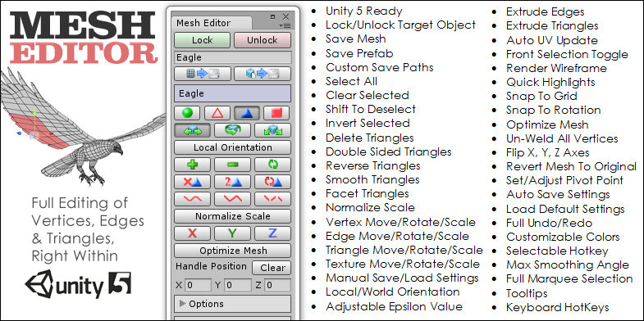

 | Mesh Editor has recently had a complete rebuild. The feature list has grown very long and contains all of the functions you would expect in an advanced mesh editing utility. Ideal for reshaping and extruding meshes right within Unity. This program makes manipulating the vertices, edges and triangles of meshes as easy as possible. | 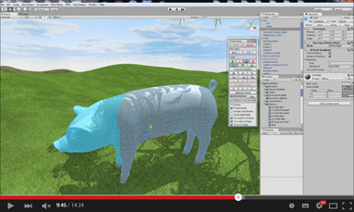  Introduction Video
Getting Started

To open the program first click on the Window menu item on the Unity menu bar, scroll down to the Mesh Editor item and then click on Open Window.

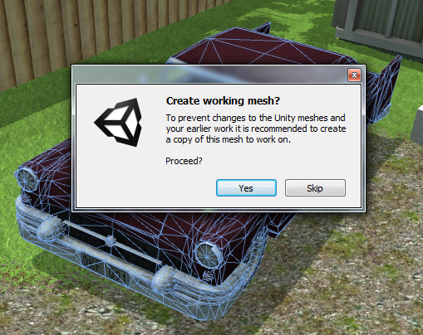
To start editing, first select a game object that has a mesh filter component attached. Note that it can have any type of collider as the program works with all colliders. Once you have selected an object the Lock button on the Mesh Editor window will become enabled. Rather than editing the original mesh of the object you will be asked if you want to create a copy of the mesh to work on so it is best to enter a unique name for the new copy before you click on the Lock button. Of course you can chose to skip the mesh copy step and edit the original instead. The copy of the mesh will be placed in the Meshes folder of the program.
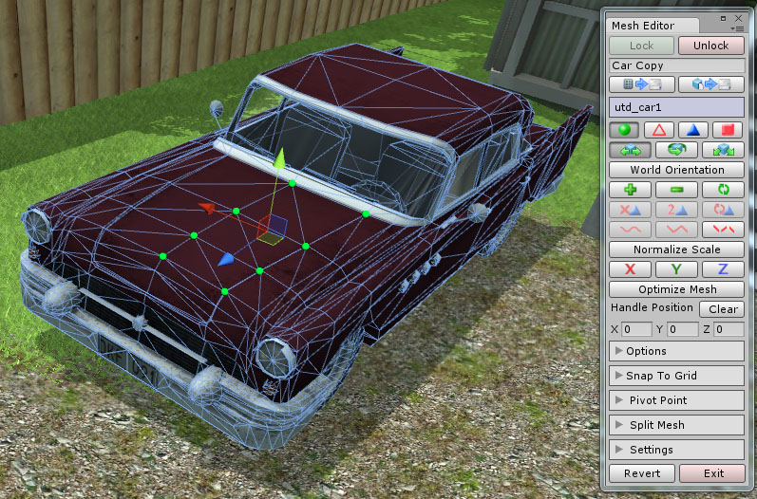
Selecting & Deselecting

You can now begin left clicking on the locked object to select the vertices of the mesh. A small green sphere will appear at the nearest vertex to where you clicked on the object. You can select multiple vertices by holding down the left mouse button while moving the cursor over the model to select more vertices. If you hold down the shift key while clicking near the selected vertices they will be deselected.
Changing Edit Modes

To work with edges, triangles and textures you can click on the buttons just below the objects name on the Mesh Editor window. As you mouse over the buttons a tooltip will let you know what the button does and the hotkey associated with that button. The same selection method works for all edit modes.

Default Hotkey

The hotkey used by default is the Ctrl key for Windows and the Command key for Mac users. If you would like to change to another hotkey you can do this in the settings area which is covered later in this tutorial. The original hotkeys will still work as well as the newly selected key.

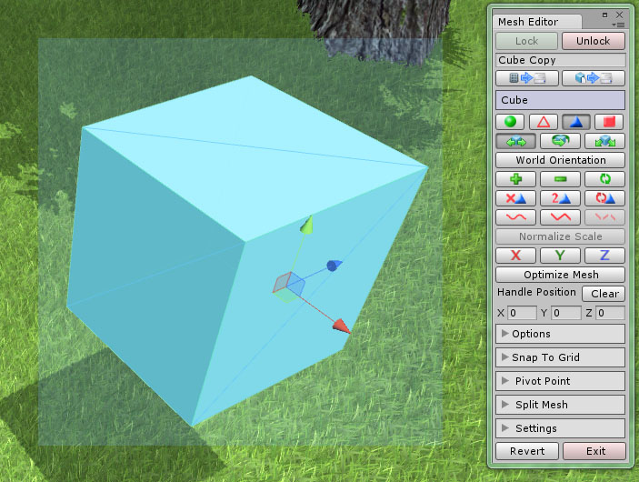
Multiple Selecting &
Deselecting

To select whole groups at a time, hold down the hotkey while left clicking and dragging the mouse and a selection box will appear. You can drag this box around the parts of the object you want to select.

To deselect simply do the same but while holding down the left shift key at the same time.

Changing Transform Modes

Just below the Edit Mode buttons are three buttons for changing the transform mode. The first is for moving (translating) the selected items, the second will rotate the items and the third will scale them. Moving, rotating and scaling work the same as for game objects in Unity. The only difference is the position of the handle when scaling and rotating. By default the handle will automatically position itself at the center of the selected items but you can override this by moving the handle to a new position. To do this first hold down the hotkey and then move the handle to a new position by dragging it. If you are in either the rotate or scale transform mode the handle will change to a translate handle while the hotkey is pressed. The scale and rotate will then happen relative to the new handle position.

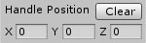
You can change the handle position manually by entering in the values for the x, y and z positions on the Mesh Editor window. To reset the handle position simply click on the Clear button just above these values.

World & Local Orientation
When moving the selected items you can choose to move them relative to the objects local space or world space by clicking on the button shown above. The button will toggle between local and world orientation.
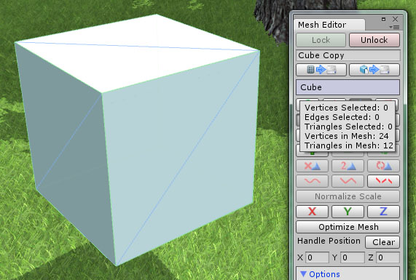
Mesh Information
To learn more about the mesh you are working on, you can mouse over the object name on the Mesh Editor window to view the mesh details. The tooltip contains information about the number of selected items as well as the number of vertices and triangles in the mesh.

Saving the Mesh as an Asset or Prefab

At any time you can make a copy of the mesh and save it as an asset in the project folder by clicking on the left button shown in the image. By default it will be given the name entered at the top of the Mesh Editor window and be placed in the Meshes folder within the program folder. You can also save the current mesh as a prefab by clicking on the right button shown in the image. The prefab will be placed in the Prefabs folder within the main program folder.

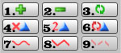
The buttons on the Mesh Editor window will enable or disable themselves depending on whether that feature is available for the current edit mode and the currently selected items.

1. Quick Select
Selects all of the vertices, edges, triangles or textures depending on the current edit mode.

2. Quick Deselect
Deselects all of the vertices, edges, triangles or textures depending on the current edit mode.

3. Invert Selection
Selects the opposite of the currently selected items.

4. Delete Triangles
Deletes the currently selected triangles.

5. Double Sided Triangles
Makes all of the currently selected triangles double sided.

6. Reverse Triangles
Reverses the currently selected triangles.

7. Smooth Triangles
Averages the normals of the selected triangles to create a smooth appearance.

8. Facet Triangles
Changes the normals of the selected triangles to create a faceted appearance.
9. Un-Weld All Vertices

This feature will split the vertices when the mesh shares vertices between adjacent triangles. This is useful if the texture coordinates and normals need to be different for each vertex.
Extruding Edges & Triangles

When you are in triangle or edge mode you can extrude the selected items by holding down the shift key before moving, rotating or scaling the items. You can extrude many edges or triangles at once even if they are not touching each other. This allows for very fast and symmetrical extrusion of meshes.

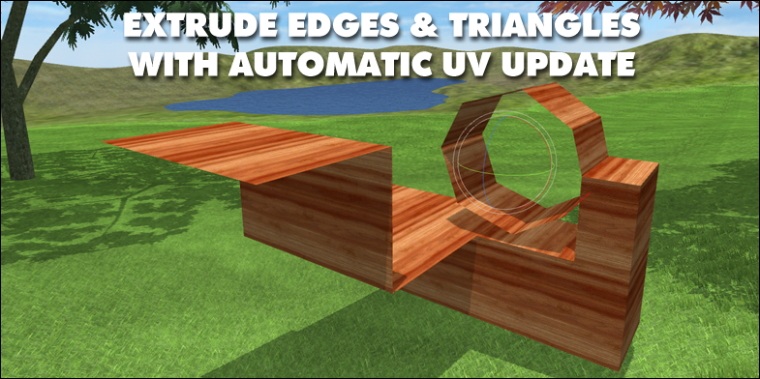

Auto Update UVs
When extruding the triangles or edges of a mesh, the texture coordinates may need to be updated. To do this, open the Options foldout area and tick the box for the Update UVs. The program will recalculate the texture coordinates using planar mapping.
Creating New Meshes and Submeshes
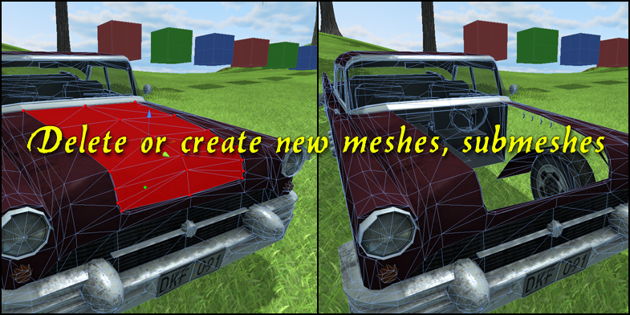
To create a new mesh or submesh first select the triangles you want to use for the new mesh, open the Split Mesh foldout section in the window and click on the Split Mesh button. The Create Submesh button will add a new submesh instead and you can assign a new material to it from within the inspector. window.
Normalize Scale

This button will become enabled when the selected mesh has irregular scale values. Normally a mesh will have the same scale values in all three dimensions. This is important for many Unity features and makes editing the mesh easier. If you find that you need to normalize the scale of a mesh click on this button to set the scale values to 1. This feature will automatically adjust the mesh size to remain visually the same within the scene view.
Optimize Mesh

This feature creates tri-strips for the existing mesh if it is capable of optimization.

Flip X, Y, Z
Clicking on these buttons will flip the selected mesh in the X, Y and Z axes.

Options
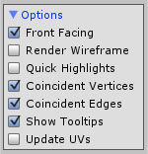
The Options foldout section contains some settings that change the default behavior of the program. The first check box enables or disables the selection of front facing polygons. The next check box turns on and off the rendering of the wireframe view which is handy if you need to select the back faces of the triangles. Below this you can choose to enable the quick highlights which render faster than the default spheres used to highlight the vertices. Normally the program will select all coincident vertices and edges when selecting them but you can turn off this behavior by un-checking the next two buttons. You can also enable or disable the showing of the tooltips using the next check box. The last check box enables the automatic updating of the texture coordinates when extruding edges and triangles.
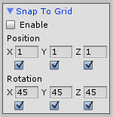
Snap to Grid
From the Mesh Editor window you can open the Snap to Grid menu foldout to access the snap options. By checking the Enable box you can choose whether to snap to a certain step size while modifying the mesh as well as snapping to a certain rotation angle while editing the mesh.
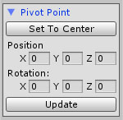
Pivot Point

You can change the position and rotation of the pivot point from within the Pivot Point foldout section. Click on Set To Center to move the proposed position of the pivot point or enter new values for the pivot point before clicking on the Update button to finalize the new position and rotation.
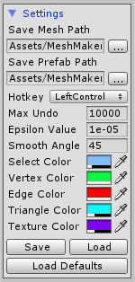
Settings Section

Within the settings foldout section you can change the default locations where the meshes and prefabs will be saved to.

You can change the default hotkey used by the program by selecting a new key to use from the drop down menu from within the Settings foldout section.

The undo and redo system used can be slow for meshes that contain more than 10000 vertices so by default this feature is deactivated for meshes above this count. If your computer is fast then you may want to increase the Max Undo value.

When selecting vertices, edges and triangles the Epsilon Value is used to compare points that are considered to be equal. If you are working on a larger or smaller scale you can change the default epsilon value.

The Smooth Angle is used during the triangle smoothing operation to determine whether adjacent triangles should be smoothed. Changing this value changes the maximum angle between triangles that should be smoothed.

The five color selection boxes change the default colors used for the selection box as well as the vertex, edge, triangle and texture highlighting.

The Save and Load buttons will save and load the settings used by the program. The Load Defaults button will reset the settings back to the original settings. The last settings will be saved automatically when the program is closed and loaded the next time you start the program.

Revert

The Revert button will reset the mesh copy back to the original mesh that was set before clicking on the Lock button. If the original mesh was a copy that was overwritten when the program started then this may make the mesh appear to disappear. In this case you will need to manually set the mesh attached to the Mesh Filter back to the first mesh attached to the object.

Exporting

To export your new creations to the OBJ format you begin by first selecting the game object/s you would like to export and then clicking on the Window menu item in Unity, hovering over the Mesh Editor menu item and then the Tools menu item before selecting the type of export you want to perform. The exported object will be saved in the Geom folder in a subfolder called Exported Objects.

Full Undo/Redo
The Undo and Redo operations use the standard Unity hotkeys Ctrl-Z and Ctrl-Y to perform the operations. This works for all transformations of the mesh as well as for most of the triangle operations. Remember that the Max Undo value determines whether the last action can be undone.

Unlock/Exit

To return control back to Unity you can either click on the Unlock button or Exit the program. You will then be able to work as normal within the Unity editor.

FAQ

There is a known issue of inverted triangles sometimes being produced while extruding. It results from two triangles sharing a vertex at a single point. The easiest solution is to extrude the triangles separately until this is fixed in a future update.

Thank You

We hope you find the program very useful for your editing needs and thank you for your support. If you have a suggestion or find a bug then please let us know by writing to support@meshmaker.com and we will do our best to add the changes to the next update.

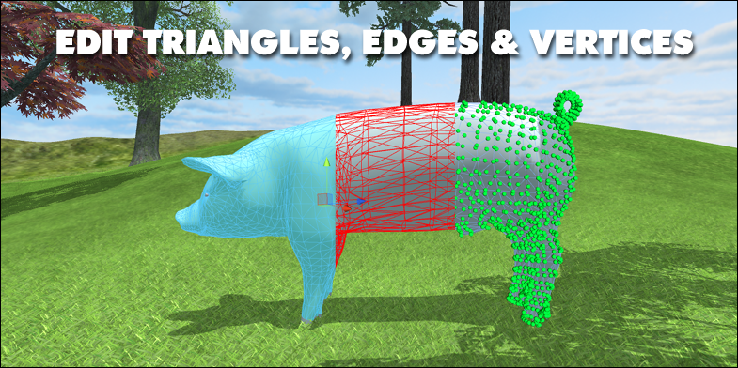

To learn more about Mesh Editor and to view the tutorial videos you can visit MeshMaker.com
Hotkeys and Button Guide

Left Click Select
Left Click + Shift Deselect
Ctrl/Command/Hotkey + Left Click & Drag Multiple Select
Ctrl/Command/Hotkey + Shift + Left Click & Drag Multiple Deselect
Ctrl Move Handle
G Switch Edit Mode
H Switch Transform Mode
P Toggle Orientation
Esc Unlock Object
Ctrl + Alt + A Select All
Ctrl + Alt + D Deselect All
Ctrl + Alt + I Invert Selected
Ctrl + Alt + E Delete Selected Triangles
Ctrl + Alt + C Double Side Selected Triangles
Ctrl + Alt + R Reverse Selected Triangles
Ctrl + Alt + S Smooth Selected Triangles
Ctrl + Alt + F Facet Selected Triangles
Ctrl + Alt + U Un-Weld All Vertices
Ctrl + Alt + X Flip X Axis
Ctrl + Alt + Y Flip Y Axis
Ctrl + Alt + Z Flip Z Axis
Ctrl + Alt + O Optimize Mesh
Ctrl + Alt + H Clear Handle Position
Ctrl + Alt + J Snap To Grid
Ctrl + Alt + P Update Pivot Point

